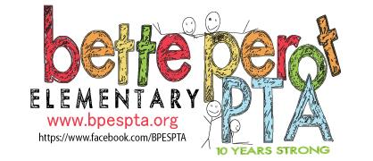
_____________________________________________________________________________

9345 General Worth Drive Keli Garrett
Fort Worth, Texas 76244 PTA President
Phone: 817-744-4600
FAX:817-744-4638

To Whom It May Concern:

The Bette Perot Elementary School PTA is currently planning our Fall Event. This will be held at our school on Friday, October 10, 2014 from 6:00 – 9:00pm. We will have games, a photo booth, food trucks on site, and much more. We are also bringing an outdoor movie for our families to enjoy at the end of our event. Our movie under the stars event will include popcorn for our families while they watch our featured presentation under the stars! This is a free event for our families.

We are looking for donations from local businesses to help make this event possible.
Specifically, we need _________________________________________________________.
The Bette Perot PTA is a local unit of the State and National Congress of Parent and Teachers which is a 501(c)3 charitable organization. Tax ID #030540984. Your donation is tax deductible.

We appreciate the support of our local community to help bring family-friendly, free event s to the students and families of Bette Perot Elementary School.

Attached you will find a donation receipt for your tax records.
Thank you for your support.

Sincerely,

Chairs name and title
Contact number
Contact email

